Wise Words: Getting Better
Gary Wise
"Turn your wounds to wisdom" - Oprah Winfrey
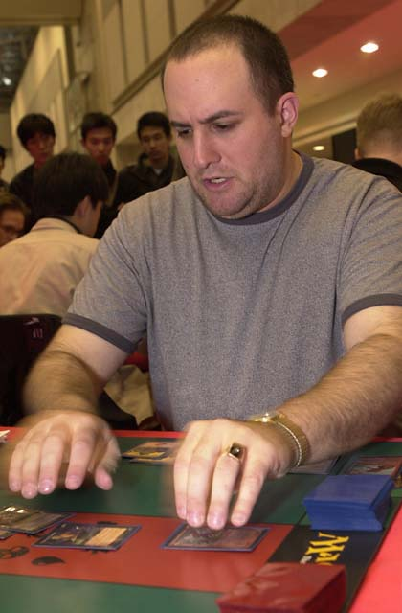
Well, I thought I'd be the last person to quote Oprah, but apparently I have a sensitive side. I've been receiving a lot of e-mail regarding what it takes to be a professional Magic player and Lady O really summed it up with this quote I found in Chicken Soup for the Sports Fan's Soul while reading last night.
As with any endeavor, being a professional Magic player is about a lot more than having a natural talent for the game. Preparation, approach, confidence, attitude...all of these individual traits combined with the ability to mix with others are important in the endeavor to get on-and stay on-the Pro Tour. With today's column, I'm going to take from personal experience as it's my experiences that I know best. I've been on Tour for four years now, so I'm hoping you might learn something.

In the Beginning... or, Learn from Your (My) Mistakes.
Like the Oprah said above, you have to make the best of your losing situations. For the first two years I played Magic (I started in March of 1995), I took an unusual approach. When it comes to my hobbies, I take a very direct approach, usually focusing on one (actually I act this way in most facets of my life, so it may be hard to relate to for some of you more diverse types) and do everything I can to get as good at it as possible.
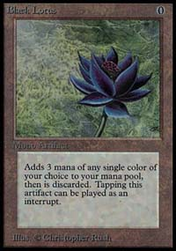
When it came to Magic, I started by making sure I had the cards I needed to build the desired decks. Like many of you, I didn't have the money for those harder to find cards (back then, one needed Moxes and power blue cards to compete) so I became a trader. Admittedly, some times I'd be ripping others off, but at other times, if there were a card I really needed, I'd give twice or even three times its value in order to get it. The key to rounding out my collection was to not think about the dollar value so much as the value of that card to my collection. It's really difficult to trade as both dealer and player: I'd recommend choosing one or the other, not both.
Once I'd gotten the cards, I started playing Type I, crushing those who didn't have the power cards, losing to my own mistakes without realizing it to those who had the jewelry. With each loss I'd complain of mana screw, with each win I'd celebrate my obvious brilliance: in short I was the equivalent of a jockey riding Secretariat and was taking credit for the horse's success.
Then one day, I was in a small card store in Northern Toronto when one of my latest victims nudges and pointed to a teenager who'd just entered the store. "That's Eric Tam." Having only played for a few months, I had no idea what that meant, so my buddy explained that Tam had just won the Canadian National Championship. Immediately, I picked up my lance, lowered my helmet and challenged Tam to a duel. Eric, who'd obviously come in looking for a game agreed, asking "Type I or Type II?" Having no clue what he was talking about, I showed him my $2000 deck and he informed me that it was Type I, but as he only had his Type II there, he'd play that against me.
He destroyed me.
It was obvious I'd just been beaten. No mana screws, no excuses, I'd just lost. The beating I'd taken showed me that regardless of the cards, I wasn't as good as others out there and that meant finding myself better players to play against. On top of that, soon afterwards, my Type I deck was stolen. While this was obviously a distressing development, this left me without the cards to compete in Constructed, meaning I had to either quit the game or take up a new pursuit: Limited.
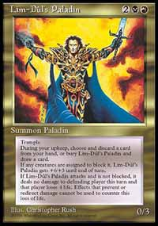
At Origins '97, Eric introduced me to Brian Weissman, with who I played around 30 games of Type 1. Getting bored of the match up, Brian suggested we do a draft, to which I once again replied 'huh?' They explained the rules to me and we drafted, and after winning my first match, I found myself paired with Mackenzie Patterson Sr. Mackenzie and I went to a third game, where my Lim-Dul's Paladin was racing well until I made a fatal error. Because I didn't understand the rules involving trample and banding, I assigned damage to both of his creatures instead of trampling over one as the rules before 6th Edition allowed. This lack of fundamental knowledge cost me the duel and the match.
Losing that way with 20 people or so watching us really woke me up. Simply, by jumping immediately into Type I, I'd failed to learn the little things. It was this lack of fundamentals that was costing me matches, so once my deck was stolen, I delved head first into Limited play. Two or three times a week, I'd draft or play sealed deck, with all of my trading efforts now aimed at getting trade stock that could be traded for packs. Game after game, I'd make mistakes that I'd file away in my head so as to not make them again.
Finally, I'd learned what there was to learn from the little local tournaments and eventually got myself acquainted well enough with Eric, Paul McCabe, Terry Borer, Gab Tsang, et al that they started letting me draft with them. This I did by helping them play test for tournaments for which I wasn't qualified and the like. Essentially, I sucked up a bit, took my beatings, showed a high degree of eagerness and learned from the thrashings I took at the hands of these professional giants. As a result, I qualified for Dallas (still learning) and Pro Tour-LA (still learning) and so on and so on. Essentially, I took my licks on the Pro Tour.
The lesson to be learned here is this: learn from your losses. Winning is a lot more fun, but you aren't going to learn from it, and if you aren't learning, you aren't getting better. Find those players in your community who you know to be the best and challenge them. Do it repeatedly and make sure that when you lose, and you will, you learn from the experience instead of making excuses.

The Will to Succeed.

If there was a PTQ within seven hours drive, I was there.
I think one of the reasons I was successful in my quest to get on Tour was that I just wanted it more than anyone else. This isn't to belittle the desires of the other players in Toronto and surrounding areas, but I was willing to take steps to further my chances of qualifying more then others.
First and foremost was my willingness to travel. If there was a PTQ within seven hours drive, I was there. My travels took me to Sandusky (seven hours), Ottawa (five hours) Detroit (four hours) etc. Granted, I was making a lot of Top 8s, inspiring me to keep making those trips, but I really believe it was this constant vigilance and ever-growing base of experience that eventually helped me to my first PTQ win.

By knowing the format in which I was competing better than anyone else, I had a distinct advantage going into that given tournament.
It wasn't just the edge of having more opportunities than others, however. The simple fact was that I put more time in than my opponents. It was my theory (and I still hold this to be true) that by knowing the format in which I was competing better than anyone else, I had a distinct advantage going into that given tournament. This meant that while others were playing all kinds of Magic, I was fully focused only on the format being played in upcoming PTQs. As a result, I knew my decks inside and out, knew the metagame just as well and could usually predict what was involved in my opponent's deck. In Limited, I played and played and played until I'd used every card in enough situation that I'd found all of the cute little combinations that made my decks work just a little better.
On top of all that, I usually entered a match with a bit of an attitude. Now, a lot of people who know me would say this didn't need to be premeditated, but I made a concentrated effort. People don't give enough importance to the psychological battle that takes place when one sits down at a tournament table. The way I psyched myself up was to go to the bathroom, stare myself down in the mirror and convince myself I was the better player, regardless of who I was playing. Professional athletes have employed this kind of tactic for a long time. Don't be afraid to psyche yourself up just because you're using your mind instead of your body. If you can make your opponent believe you're better than they are, chances are they won't be winning. The best way to do this is by exuding confidence.

Your Peers
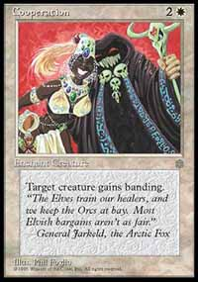
It doesn't matter how good you get at this game, you can always learn something from others. One reason I go to Grand Prix is because I know that I'm going to learn a lot from drafting with other professionals and from watching them draft. It's my experience that my initial instincts, while not too bad, are usually full of gaps that will only be filled by the expressed opinions of others.
When initially addressing a new environment, you should probably take a shot at doing it yourself, but once you've formed some notions, put them to the test by discussing them with others. It's important not to reject those ideas others have too quickly (an offense of which I've been guilty on occasion) as even the strangest nugget could have merit, if not now, then when the environment changes. I learned this by teaming with Alan Comer for three years. Players with unconventional views like Alan have a way of opening your eyes to new possibilities. It's always a benefit to have someone like Alan or Tom Guevin who will provide you with ideas that, while not always applicable, will make you aware of the fact that your tunnel vision does not span the entire format.
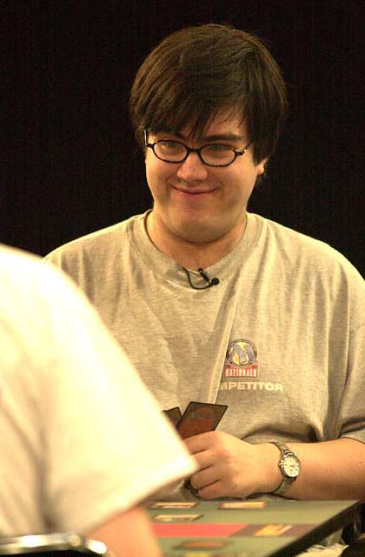
All this is the reason that those players with solid team foundations have been doing well in constructed PTs as of late. Zvi Mowshowitz, for example, is an excellent player, but without a solid team around him, it seems unlikely that he would have won PT Tokyo. Having been on a team with he and Scott Johns for a long time, I know that Zvi is brilliant with regards to forming deck ideas while Scott is as good as anyone at tightening those decks. Neither player would be complete without the other. Zvi won Tokyo because he had the viewpoints of many excellent deck builders and players including Scott, Kai Budde, Warren Marsh, Ben Ronaldson and John Ormerod (the principal designer of 'the Solution') at his disposal.
The question you need to address then is how to find a group of players to work with. First, you have to stay realistic. I've had players who have never qualified for a Pro Tour e-mail me asking me to be on a team with them or exchange information with them, and while I try to be polite by saying if they want, they can send me their thoughts so I can appraise them, it just isn't realistic for a pro who doesn't know you or your game to agree to work with you unconditionally. What you want to do is find a group of players who are on an equal or slightly higher level than you are, so the relationship is one of equality instead of teacher-student. It's important that you get along with these people, so use some common sense in choosing those you associate on this level. It's also important that you choose people who are capable of functioning in a team environment, caring for more than just their own interests. There are players on Tour who have proven time and again that they are incapable of functioning in a team dynamic. Not too surprisingly, those players are able to sit on natural talent to keep qualifying, but they haven't achieved what most would call success.

The Little Things
So, once you've packaged all of that stuff I've listed together, all that's left is spreading the mortar between the bricks. It's important to do all the little things that make your tournament preparation/experience complete. Keep your eyes open in order to see what all of your potential opponents are playing. Shower and shave, brush your teeth, do all the silly little things one might neglect before each tournament so you're feeling your best (It's hard to be self confident when you know you're looking bad), as feeling good about yourself will translate into a confident appearance. Take a professional approach: you're trying to be a professional.
Once you actually find your way to the Pro Tour, you may feel overwhelmed by the conglomerate-sized teams with whom you, a mere individual, must compete. Every member of those teams went through the same thing once upon a time, and it was the consistently strong finishes, deck building ability or overall skill that instilled in others the desire to work with them. Start proving Yourself on tour and suitors will come.
That's about it for this week. Next weekend, 'GP Madison,' otherwise known as Bob Maher's wedding is going on. Congrats to Bob and Courtney and the best of luck in their years together. As always, if you feel the need to send me a question or comment on the column's content, you can e-mail me at JgaryWise@yahoo.com. Have a good week.

